Name:
Dr. Attis
9th Literature
Date:

Argument Guided Notes

Standard: 9-10.WS.1. Write arguments to support claims in an analysis of substantive topics or texts, using valid reasoning and relevant and sufficient evidence

- An argument is a _________________, _________________ way of demonstrating that the writer’s position, belief, or conclusion is __________________. In short, arguments seek to make people ___________________ that something is true or to persuade people to __________________ their beliefs or behavior.
- An argument expresses a point of view
- This point of view is called your BELIEF.
- Your BELIEF is your CLAIM in an argument
- A claim is your basic ___________ about a particular ______________, _______________, __________________, or _________________.
  - Some women in the workplace are underpaid.
  - Smokeless tobacco could be more harmful than cigarettes.
  - Standardized tests could devalue the purpose of instruction.
  - Most of the present generation lacks the discipline to live a technology-free life.
- Two ways that you can support a claim is by using ___________ and _______________
- A counter claim or counter argument is a solid and ________________ argument that opposes or _______________ with your claim.
  - Two parts of a counter claim: concession and rebuttal
- A counter claim is important because it makes the argument _____________. It gives you the chance to ________________ to your reader’s __________________ before they have finished reading. It also shows that you are a reasonable person who has considered _______________ sides of the debate.
- Signal words in a counterclaim:
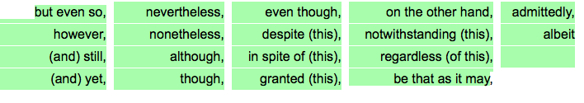
- A concession is ______________________ of the opposing viewpoint/other side of the argument.
- A rebuttal is a _______________ or _______________ response to a counterclaim. The object of the rebuttal is to take into account the ideas presented in the counterclaim and explain why they _____________ persuasive enough, _____________ enough, or ___________________ enough to outweigh your own claim.
- When you refute a claim, you are arguing ________________ a claim or proving it to be wrong.
- To qualify an argument means to “_____________-agree” with another person’s argument or position but also disagree with part of it.
- Differences between argument and persuasion
An Argument Essay | A Persuasive Essay
Makes claims based on _______________ evidence | May make claims based on _________________
Makes ___________________. The author takes __________________ views into account. | May ______________ take opposing ideas into account
Neutralizes, defuses, deactivates or “____________” serious opposing ideas

Convinces audience through the ________________ and ____________ of the claims and proofs offered  Often __________________ texts or ideas to establish a position | Persuades by appealing to the audience’s _______________ or by relying on the character or _______________ of the writer – less on the merits of her or his reasons and evidence.
________________-based | ________________-based
the writer leaves it to the audience to decide whether a course of action is desired | Moves people to action

- Argument response paragraph suggested outline
- Claim
- Defense #1
- Explanation of defense
- Defense #2
- Explanation of defense
- Counter claim
- Closing sentence

- Counterclaim response paragraph suggested outline
- Topic Sentence (introduce counter claim)
- Give rebuttal
- Give evidence
- Explain how evidence weakens the opponents claim
- Closing sentence.

