Name:
Dr. Attis
9th Literature
Date:
Literary Focus: Appeals (Logical and Emotional)
Assignment #1 __________/

Objectives
- Students will understand and analyze emotional and logical appeals
- Students will understand and analyze diction
- Students will understand a text by summarizing
- Students will recognize and discuss the main ideas and its supporting details

Speech: Ain’t I a Woman, by Sojourner Truth
- Lexile 720
- Pg 536

Assignment Length
- two class periods

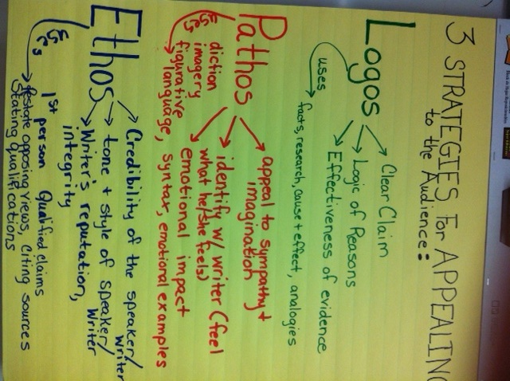

Context: https://www.youtube.com/watch?v=Y4PVu2hc8Sg , https://www.youtube.com/watch?v=-0YR1eiG0us

Work Session
Whole Group Reading: _______/5pts (EC)
- Ain’t I a Woman by Sojourner Truth, pg 537

Partner CW: ________/7
- Reading Focus A (Summarizing) pg 537
- Literary Focus B (Logical and Emotional Appeals) Pg 537
- Monitoring your Reading: In paragraph 3, Truth rejects the ideas that intellect is a requirement for equal rights. What does she believe is the only qualification a person needs? Pg 537
- Analyzing Argument: What is the irony that Truth’s points out in paragraphs 4 and 5? Pg 537
- How does Truth support her argument that women should have equal rights?
- How does Truth compare herself to men?
- What is ironic about Truth’s discussion of woman’s intellect?
Individual Quiz: ________/5 (pg 539)
- Reading Focus #3
- Literary Focus (Literary Analysis) #7, 8
- Literary Skills (Diction) # 9
- Literary Skills Review (Setting) 13
Writing Focus: Write a short speech in which you present an argument, about a social issue, using emotional appeals.

